**Create Database:**

Create database airline

**Create table for passenger:**

Create table passenger

(

P_ID int primary key,

Fname varchar(20) NOT NULL,

Mname varchar(20) NULL,

Lname varchar(20) NOT NULL,

mno int,

);

Insert into passenger values(14014,'Ashley','Peter','Rodriques',9875469876)

Insert into passenger values(14015,'Royce','Henry','Rodriques',9875469880)

Insert into passenger values(14016,'Kavit','Girish','Shah',9875549870)

Insert into passenger values(14017,'Shawn','Joseph','Rebello',9826549876)

Insert into passenger values(14018,'Jon','Eddard','Snow',9875446895)

Select * from passenger

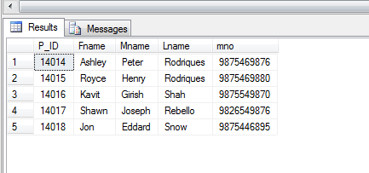

**Not null constraints**

Insert into passenger values (14019,Null,'Michael','Rebello',9765412369)

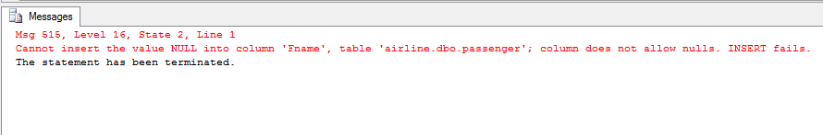

**Null constraints**

Insert into passenger values (14020,'Avi','','Shah',9894631279)

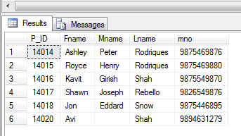

**Create table for staff1:**

Create table staff1

(

s_id varchar(20) PRIMARY KEY,

Fname varchar(20) NOT NULL,

Mname varchar(20),

Lname varchar(20),

Salary int,

Experience int default 5,

);

Insert into staff1 values(2021,'Rajesh','Shailesh','Ashar',25000,7)

Insert into staff1 values(2022,'Clive','James','Rodrigues',26000,7)

Insert into staff1 values(2023,'Sanket','Pravin','Shah',25000,2)

Insert into staff1 values(2024,'Alric','Tywin','Lannister',40000,3)

Insert into staff1 values(2025,'Catelyn','Eddard','Stark',10000,10)

Select * from staff1

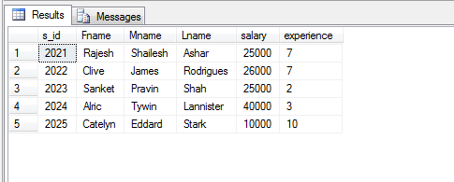

**Default Constraint**

Insert into staff1 values(2026,'Danaerys','Arryn','Targeryn',10000,default)

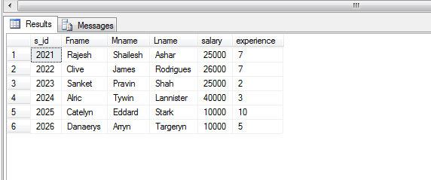

**Primary Key Constraints**

Insert into staff1 values(2025,'White','W','Walker',5000,2)

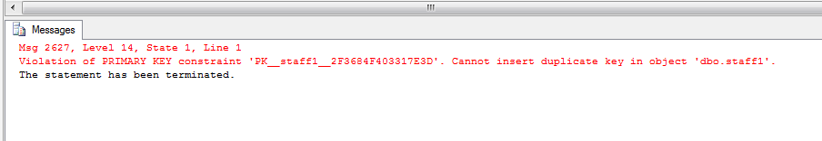

**Create table for plane:**

Select * from plane

Create table plane

(

Pid int unique,

Pname varchar (20),

Capacity int,

);

Insert into plane values(2025,'Indigo',4000)

Insert into plane values(2026,'Emirates',4500)

Insert into plane values(2027,'Kingfisher',3500)

Insert into plane values(2028,'Indian Airlines',5000)

Insert into plane values(2029,'Jet Airways',5540)

select * from plane

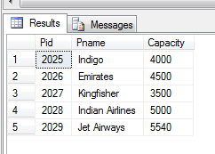

**Unique Constraints**

Insert into plane values(2029,'Etihad',5000)

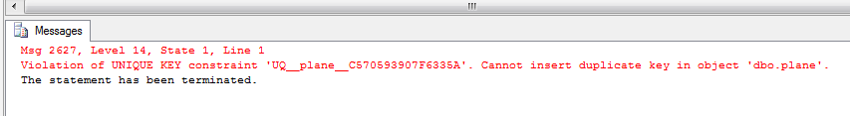

**Create table for country:**

Create table country

(

Pid int primary key,

A_time varchar (20),

D_time varchar (20),

Airport varchar (20),

Foreign key (Pid) references plane(Pid)

);

Insert into country values(2029,'12:00','13:00','Shivaji Terminal')

Insert into country values(2025,'8:00','10:00','Dubai Terminal')

Insert into country values(2026,'9:00','11:00','London Terminal')

Insert into country values(2027,'3:00','5:00','Chicago Terminal')

Insert into country values(2028,'15:00','17:00','Australia Terminal')

Select * from country

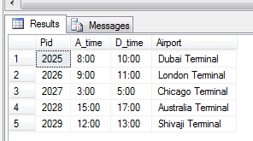

**Foreign key constraints**

Insert into country values(2030,'12:00','14:00','Bosnia Terminal')

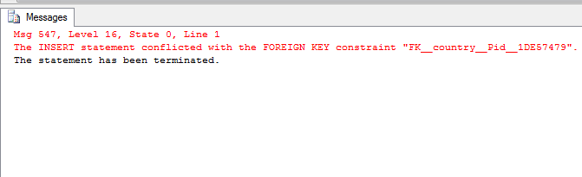

**Create table for luggage:**

Create table luggage

(

Lid int primary key,

L_Wt decimal(10,2),

L_No int,

check (L_Wt<60.00),

);

Insert into luggage values(2026,50.22,4)

Insert into luggage values(2027,50.41,3)

Insert into luggage values(2028,50.56,4)

Insert into luggage values(2029,50.60,5)

Insert into luggage values(2030,59.99,4)

Select * from luggage

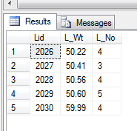

**Check constraints**

Insert into luggage values(2031,60.34,4)

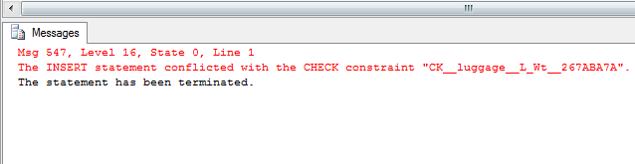

**Create table for ticket:**

Create table ticket

(

Tid int primary key,

pid int,

Fname varchar(20) NOT NULL,

Mname varchar(20) NULL,

Lname varchar(20)NOT NULL,

Fare int,

Destination varchar (20),

);

Insert into ticket values(2510,14014,'Ashley','Peter','Rodriques',12300,'Australia')

Insert into ticket values(2511,14015,'Royce','Henry','Rodriques',12500,'USA')

Insert into ticket values(2512,14016,'Kavit','Girish','Shah',15000,'Russia')

Insert into ticket values(2513,14017,'Shawn','Joseph','Rebello',11300,'Afghanistan')

Insert into ticket values(2514,14018,'Jon','Eddard','Snow',12000,'England')

select*from ticket

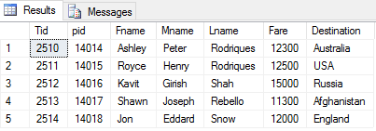

**TRIGGERS**

**Insert trigger**

create trigger tri1 on passenger

FOR INSERT

AS

declare @pid varchar(10);

declare @fname varchar(20);

declare @lname varchar(20);

declare @mno varchar(10);

select @pid=i.P_ID from inserted i;

select @fname=i.Fname from inserted i;

select @lname=i.Lname from inserted i;

select @mno=i.mno from inserted i;

set @pid='Inserted Record -- After Insert Trigger.';

Insert into passenger

(P_ID,Fname,Lname,mno)

values(@pid,@fname,@lname,@mno);

PRINT 'AFTER INSERT trigger fired.'

GO

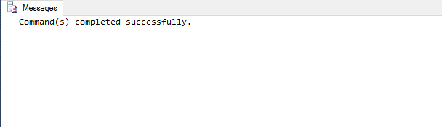

Insert into passenger values

('14019', 'Albert', 'Mendonca', '8286864601')

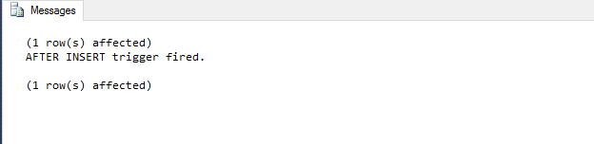

Select * from passenger

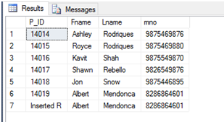

**Update Trigger**

create TRIGGER trgAfterUpdate ON [dbo].[ticket]

FOR UPDATE

AS

declare @tid int;

declare @fname varchar(20);

declare @mname varchar(20);

declare @lname varchar(20);

declare @fare int;

select @tid=i.Tid from inserted i;

select @fname=i.Fname from inserted i;

select @mname=i.Mname from inserted i;

select @lname=i.Lname from inserted i;

select @fare=i.Fare from inserted i;

if update(Fare)

set @fname='After Update trigger'

Print 'After Update Trigger Fired'

Go



Update ticket

set Fare=13500

where tid=2510

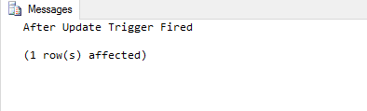

Select * from ticket

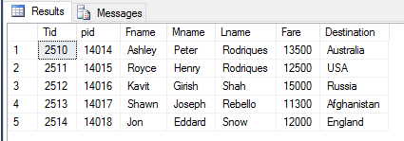

**Delete Trigger**

Create trigger Del_trigger on ticket

After Delete

As

Begin

Select pid, Fname, Mname, Lname from Deleted

End

Go



Delete from ticket

where Tid=2512

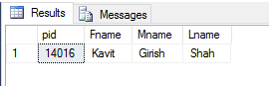

Select * from ticket

